[add your country/organization logos here]

Cost of implementing
Civil Registration and Vital Statistics systems

[Country name]
[Year of costing data]

This report was generated using the CRVS Budgeting & Costing Tool developed by the Swiss Tropical and Public Health Institute and the University of Melbourne as part of the Bloomberg Philanthropies Data for Health Initiative

About the CRVS Budgeting and Costing Tool
The purpose of the CRVS Budgeting & Costing Tool is to help planners and managers to determine the costs of implementing civil registration and vital statistics (CRVS) systems.
This Tool can be customized to country context and covers all aspects of a CRVS system comprising start-up costs, training costs, community-level service delivery costs, as well as support, supervision, and management costs at all administrative levels. Additionally, the Tool has a budgeting element that can be used to estimate budgets for CRVS systems.
The Tool automatically produces the following outputs:
- Total program costs for baseline year by activity and input type
- Average costs per registration
- Key drivers of costs
The information collected could be used to strengthen budget preparation and justification in the annual budget preparation process; and to assist in CRVS system implementation - measuring efficiency while identifying inefficiencies.
The CRVS Costing Tool consists of a single Excel file (.xlsx) where users define their assumptions for the costing exercise, collect general information about the country and cost information, and are provided with the results of the analysis. It is organized in three main sections: costing section, budgeting section and modelling section.
First, the tool allows to collect general information about the country and to define the assumptions for the analysis (eg discount rate, exchange rate, life span of different resources, etc.). Once this information is entered, the user moves to the second sub-section where all the cost data will be entered. The collection and analysis of CRVS costs is based on activities. We identified 6 groups of activities: start up activities, governance activities, program management, supervision, refresher training and Direct CRVS activities. Finally, a third subsection displays the results of the analysis based on the information entered in the previous steps.
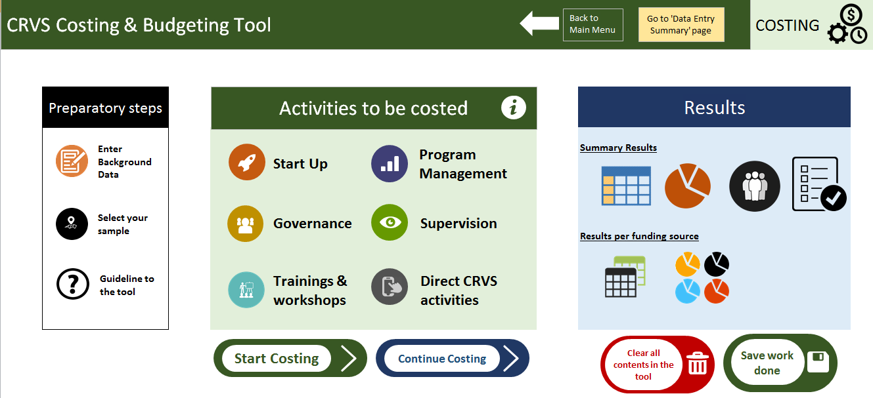

Costing methodology
This tool considers both financial and economic costs. Financial costs represent the accounting cost of developing and implementing an intervention, whereas the broader notion of economic costs, captures the opportunity cost of the resources used in the intervention, regardless if a financial cost was incurred (ie even if they did not involve a monetary payment). Differences arise between financial and economic costs for goods or services for which there are no financial transactions, and where the price of the good does not represent its actual value. This is particularly important in programs with donated goods, working with volunteers or when valuing capital costs. The economic cost or value of donated goods and services will be estimated by taking their equivalent market prices. Therefore our tool estimates the total financial and economic cost of CRVS implementation in a country. It produces several cost estimates including total cost, average cost per registration, and further analyses and disaggregation (eg cost per funding source, cost per CRVS milestone, cost per activity group or cost per type of resource used).
The tool assumes a systems perspective for the costing study where only costs incurred by the CRVS system are included and other costs such as household out-of-pocket expenses associated with death registration are excluded. Although choosing a more comprehensive approach with a societal perspective would be preferable, the objective of this study is to provide governments and other institutions with an estimate of the cost of CRVS routine system as an input for future policy decisions. As a consequence, this audience will be most interested in those costs that could fall under their budgets, rather than those incurred by households.
A combination of top-down and ingredient-based methodologies are used to estimate the costs of implementing CRVS systems. The top-down costing approach involves allocating overhead and shared costs of the system to each sampling unit, where applicable, using appropriate allocation rules. The ingredient based costing approach is generally defined as a valuation technique which starts with a detailed identification and measurement of all the inputs required for an intervention, followed by conversion into value terms to produce a total cost estimate. In this study, the ingredients based approach are used to estimate the total costs for all CRVS related activities by listing all the possible inputs, measuring quantities and valuing all inputs required for a functioning CRVS system.
The following human resource categories are considered and valued depending on the setting:
- Registrar
- Registrar assistant
- Other CR staff
- Statistician
- National manager & supervisor
- Sub-national manager & supervisor
- Consultant
- Other.

Total costs for the registration are estimated by aggregating the costs of the different inputs. Average/unit costs are estimated by dividing the total costs by the units of outputs (i.e. number of registrations) produced. Unit cost estimates produced from this study will be used to model costs at full national or sample scale. Note that the same tool will be used for modelling estimated costs of alternative delivery scenarios in the three study countries, and possibly others.

Costing results

Background information
Provide a brief description of the setting:
- Country profile
- CRVS structure
- Activities involved in CRVS implementation
- Rationale of this costing exercise

General Indicators | Value |  | Year
Population (thousands)
Population growth rate (%)
Median age (years)
Crude mortality rate (%)
Birth registration coverage (%)
Death registration coverage (%)
Cause of death registration coverage (%)

Economic Indicators | Value | Year
Gross domestic product (GDP) per capita
Total health expenditures per capita, PPP
World Bank income classification
Average annual inflation rate
Average annual salary growth

Basic assumptions for the costing
Describe the assumptions made during the costing exercise and their rationale (e.g. discount rate, useful life of capital cost, unit cost of goods or services…

Assumption | Value
Discount Rate
Useful life years of buildings (years)
Useful life years of equipment (years)
Useful life years of vehicles (years)
Useful life years of Trainings (years)

Regions or facilities included in the costing study

Describe the sampling frame and the rationale for selecting the sample in this specific CRVS costing exercise.

Sample

Summary of cost of implementing CRVS systems
Describe the main results of the costing exercise in the light of the methods and assumptions made during the costing exercise.

Start Up activities
Governance activities
Refresher training & workshops
Program Management
Supervision
Direct CRVS activities
TOTAL
Cost per Registration

Graph 1

Total cost of implementing CRVS per cost category
Report the disaggregation of the cost per input and discuss reasons for the cost structure.
Input | Total Financial Cost in 2017 () | % of financial costs | Total Economic Cost in 2017 () | % of economic costs
Start-up costs
Trainings, workshops & meetings | - | 0% | - | 0%
Other start up | - | 0% | - | 0%
Total start-up costs | - | 0% | - | 0%
Recurrent costs
Workshops, meetings, trainings and supervision visits | - | 0% | - | 0%
Personnel | - | 0% | - | 0%
Communications | - | 0% | - | 0%
Maintenance | - | 0% | - | 0%
Supplies & other recurrent | - | 0% | - | 0%
Total recurrent costs | - | 0% | - | 0%
Capital costs
Buildings | - | 0% | - | 0%
Equipment | - | 0% | - | 0%
Vehicles | - | 0% | - | 0%
Consultants | - | 0% | - | 0%
Total capital costs | - | 0% | - | 0%
Total Annual Costs | - | 0% | - | 0%

Graph 2

Graph 3

Cost of implementing CRVS per funding source

Describe the distribution of cost per funding source.

Graph 4

Share of the cost supported by each stakeholder

Donor

Staff time allocation
Describe staff requirements as resulted from the costing study.

 | Total number involved |  | FTEs*
Registrar
Registrar assistant
Other CR staff
Statistician
National manager & supervisor
Sub-national manager & supervisor
Health personnel
Consultant
Community key informants
Other
*FTE: Full Time Equivalent

Conclusions/summary
(Optional) – provide a brief overview of main results and implications

Available at https://crvsgateway.info/file/10242/3104 (Excel file, direct download)

